1. **Create Tables**

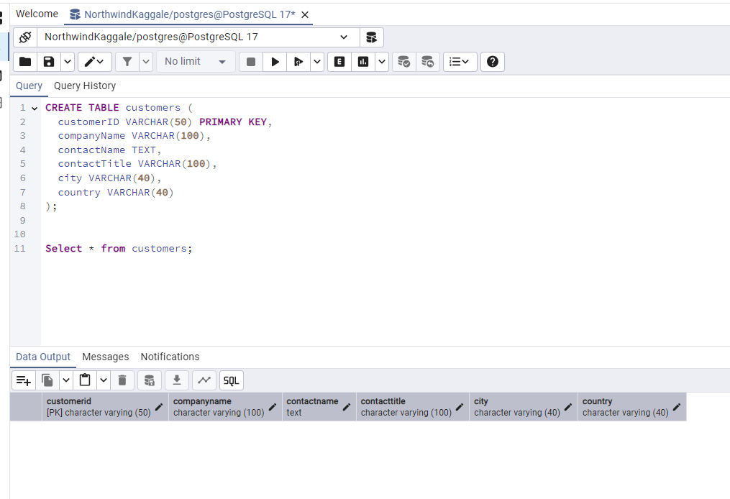

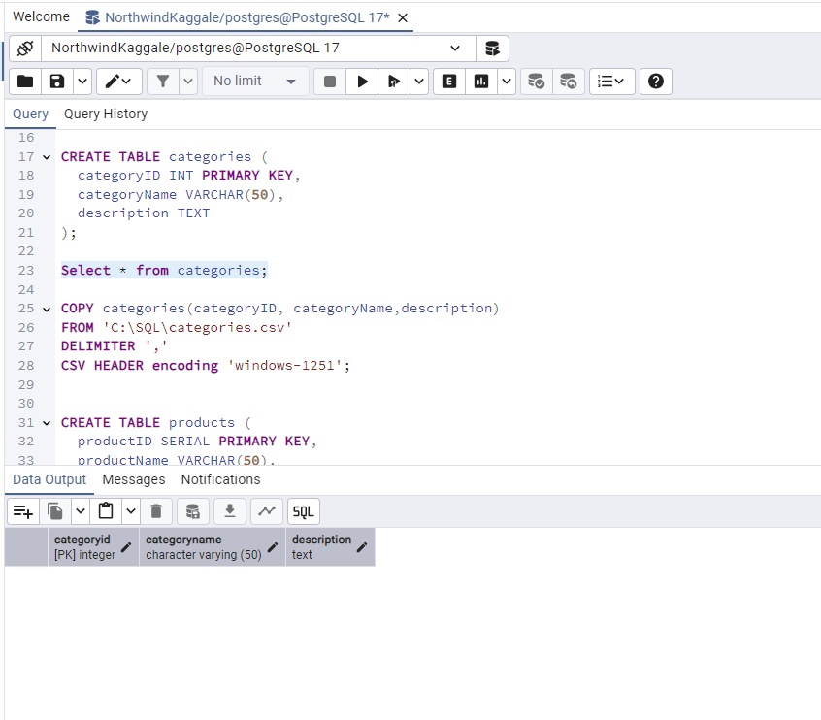

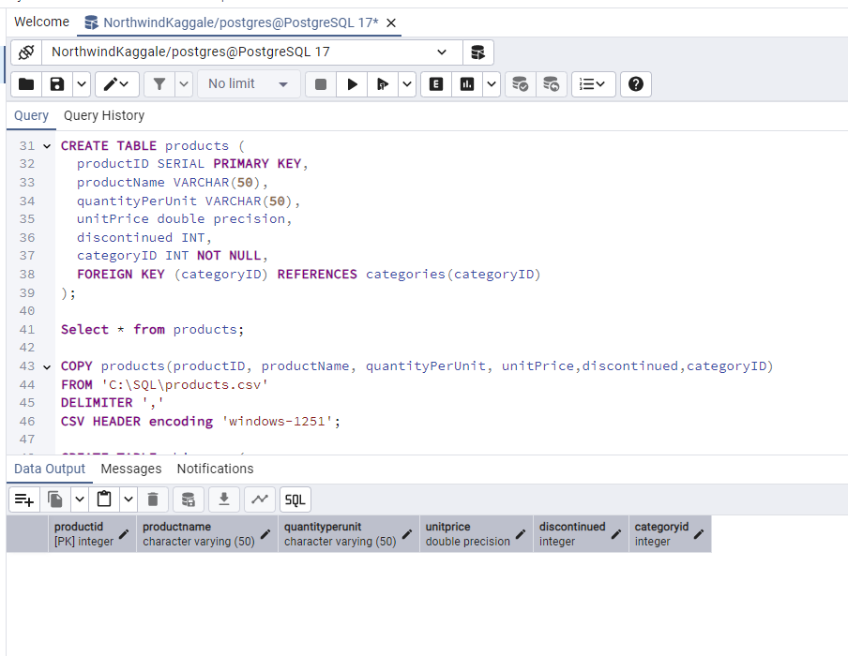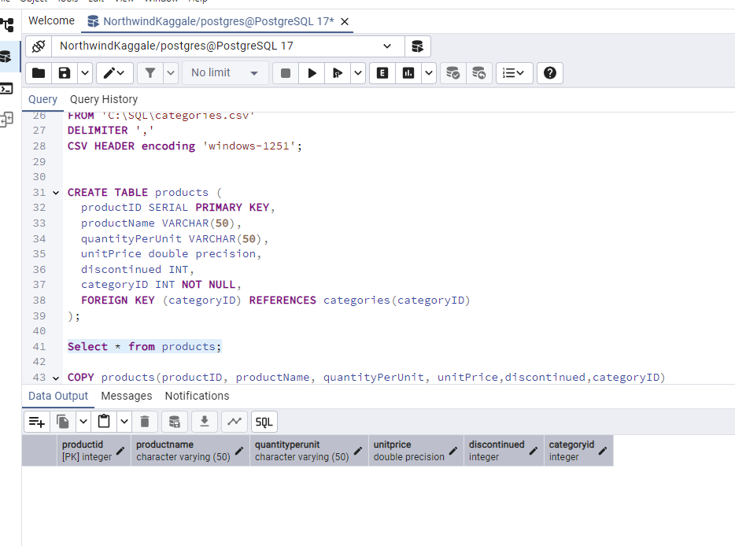

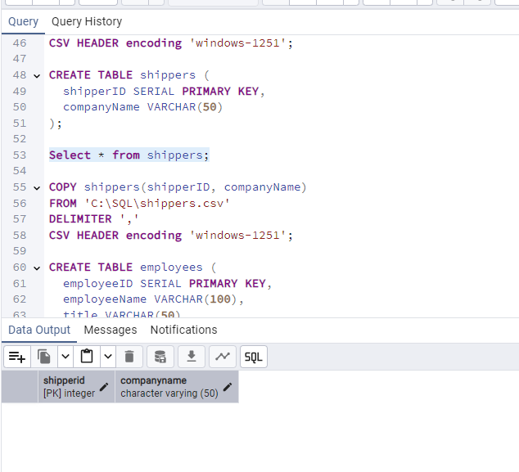

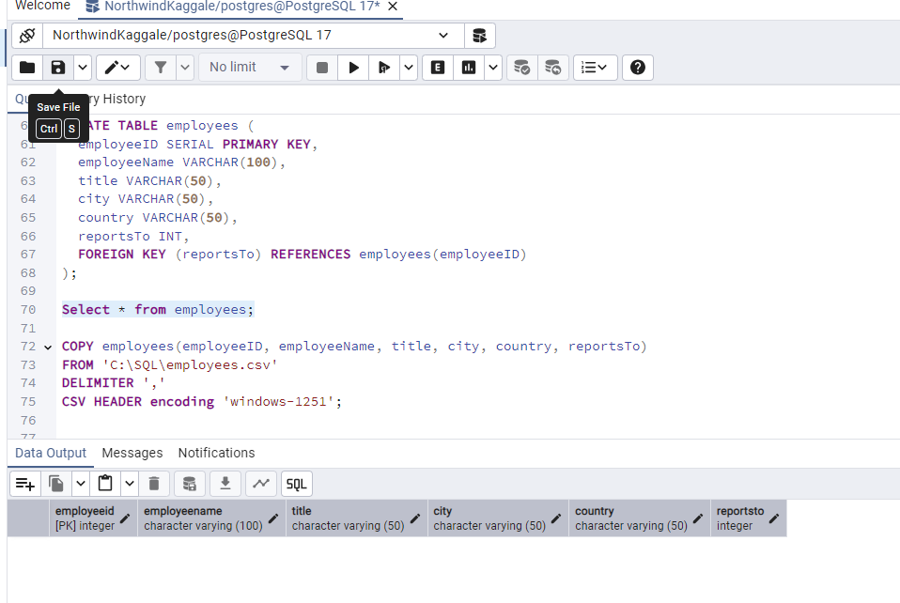

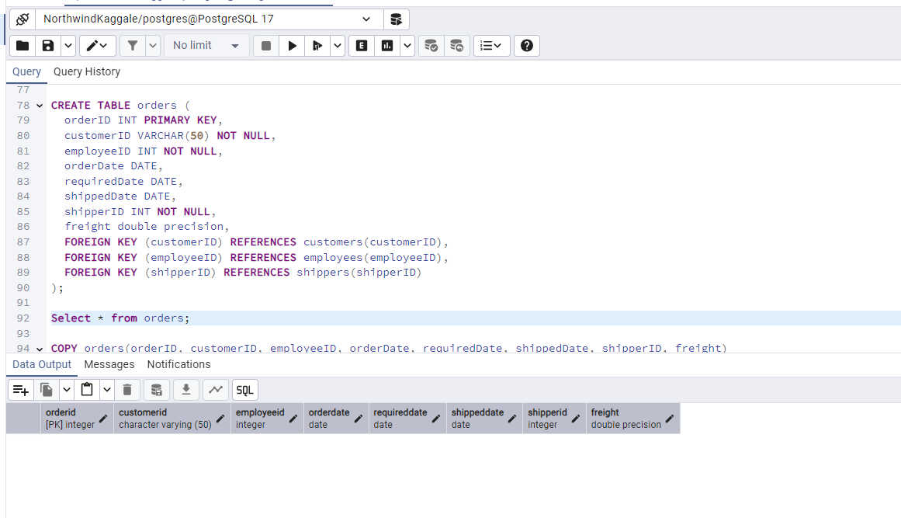

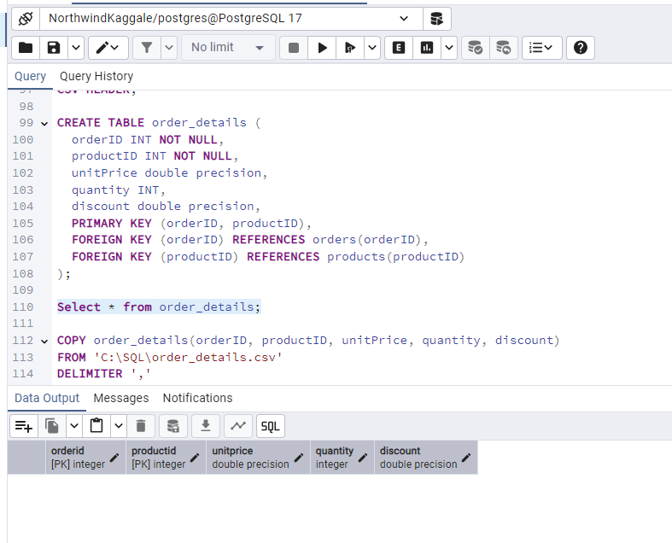

COPY customers(customerID, companyName, contactName,contactTitle,city,country)

FROM 'C:\SQL\customers.csv'

DELIMITER ','

CSV HEADER encoding 'windows-1251';

COPY categories(categoryID, categoryName,description)

FROM 'C:\SQL\categories.csv'

DELIMITER ','

CSV HEADER encoding 'windows-1251';

COPY products(productID, productName, quantityPerUnit, unitPrice,discontinued,categoryID)

FROM 'C:\SQL\products.csv'

DELIMITER ','

CSV HEADER encoding 'windows-1251';

COPY shippers(shipperID, companyName)

FROM 'C:\SQL\shippers.csv'

DELIMITER ','

CSV HEADER encoding 'windows-1251';

COPY employees(employeeID, employeeName, title, city, country, reportsTo)

FROM 'C:\SQL\employees.csv'

DELIMITER ','

CSV HEADER encoding 'windows-1251';

COPY orders(orderID, customerID, employeeID, orderDate, requiredDate, shippedDate, shipperID, freight)

FROM 'C:\SQL\orders.csv'

DELIMITER ','

CSV HEADER;

COPY order_details(orderID, productID, unitPrice, quantity, discount)

FROM "C:\SQL\order_details.csv'

DELIMITER ','

CSV HEADER encoding 'windows-1251';